**Hypothesis Testing**

Null Hypothesis:  The perception of the transition smoothness (from tradition to mobile banking) is indifferent to gender

Alternative Hypothesis: Gender plays a role in the transition smoothness

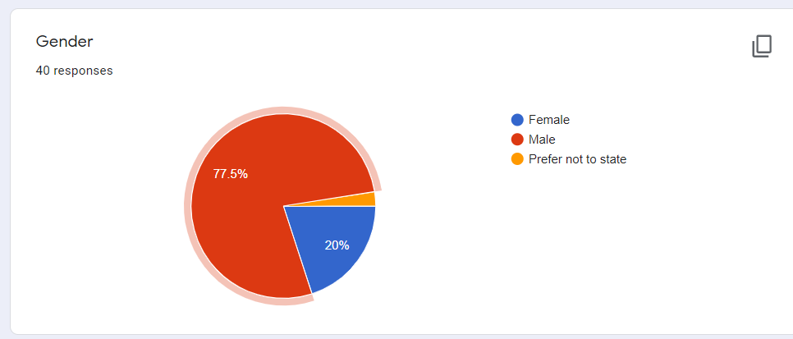

Note in the below chart ‘smooth, picked up quick(ly)’ has two variations’ due to the wording correction. Need to be grouped together.

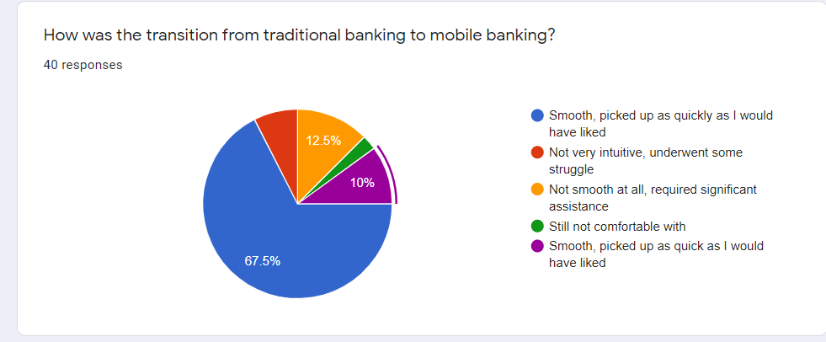

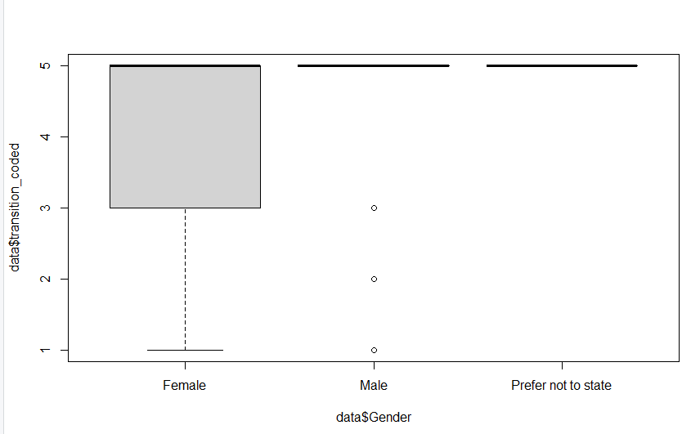

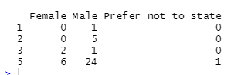

Here

Still not comfortable with - 1

Not smooth at all, required significant assistance - 2

Not very intuitive, underwent some struggle - 3

Smooth, picked up as quickly as I would have liked – 5

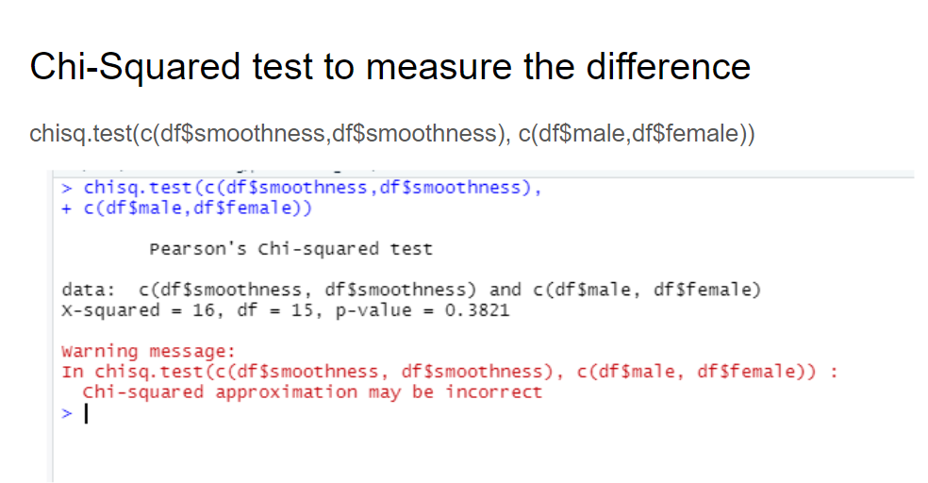

Not enough evidence to reject the null hypothesis.

Fails to reject the null hypothesis that is the transition smoothness is indifferent to Gender.

The data is less than 5 even. So Chi-Squared rule of thumb also not covered.

**Hypothesis Test 2**

Null Hypothesis: The feedbacks (optional) received in this particular Questionnaire are equally given by Males and Females

Alternative Hypothesis: Females has given more feedback.   
  
  
Will check for the statistical significance with the available (limited) data.

Feedback given - 1

Feedback not given - 0

